Welcome to the Sydney Triathlon 2010 World Cup!

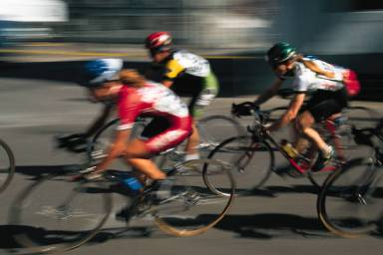

The Triathlon

On April 18, the best athletes assembled in the history of the triathlon will contest for the Sydney Triathlon 2010 World Cup. The triathlon will be held on the 2000 Olympic course, starting and finishing on the forecourt of the Sydney Opera House.

Prize money: $50,000

Start time: Women start at 9:30 am. Men start at 12:30 pm.

**The Course**

1.5 km swim: A testing lap around Farm Cove, beside the Opera House, with a pontoon start. Wetsuits are allowed.

40 km cycle: A six-lap circuit of downtown Sydney and the Botanic Gardens.

10 km run: A two-lap circuit of downtown Sydney and the Botanic Gardens.

**Best Views**

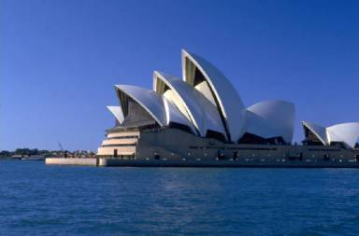

The Sydney Opera House

Sydney's most famous landmark, the Sydney Opera House, will provide the best viewing area for the triathlon. This event is expected to attract a large crowd, so get there early for the best vantage spots.

The start and finish lines and the transition areas of both the men's and women's races will be on the forecourt of the Opera House. The Opera House will also provide a fine view of the swim course in Farm Cove. A large video screen will show scenes from the races through downtown Sydney and the Botanical Gardens.

The rest of the course

Macquarie Street, College Street, the Botanical Gardens, and the Domain will also provide good viewing areas.

**Public Transport and Road Closures**

How to get there

Public transport is recommended. Take trains, busses, and ferries to Circular Quay.

Road closures

Special event clearways will operate along the route from 1 a.m. until 6 p.m. on April 18.

Public roads around the Domain, Botanical Gardens, Macquarie Street, College Street, and Art Gallery Road will be closed.

Spectators will be able to cross the course during the event at specific crossing points only.

An exclusion zone will also operate on Sydney Harbor around the swim course from 12 noon on April 17. This exclusion zone will be 60 meters off Opera House Point to 60 meters off Lady Macquarie’s Chair, extending 40 meters off the shore into Wolloomooloo Bay.

**The Athletes**

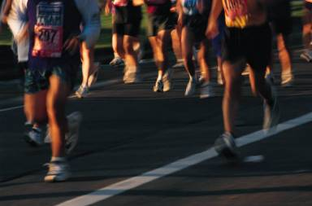

75 women and 75 men will compete in the Sydney Triathlon 2010 World Cup event. Here are some of the athletes to watch.

Nicole Walton, USA

World Ranking: 1

Record: Multiple World Cup champion and former Sydney World cup winner.

Colin Fuller, New Zealand

World Ranking: 1

Record: Olympic gold medalist and two-time World cup champion. Strong in all three events.

Peter Flower, Hungary

World Ranking: 6

Record: One of the best runners in the sport and a multiple World Cup winner.

Rachel Johns, Canada

World Ranking: 7

Record: A run specialist. Considered a major threat. A former world silver and bronze medalist.

Romana Rehula, Czech Republic

World Ranking: 12

Record: Czech athlete who trains in Australia. Finished fourth at the Beijing Olympics.

Andre Suys, Belgium

World Ranking: 9

Record: A cycling specialist. Former World Cup winner. One of the most consistent performers in the sport.

Derek Acker, Germany

World Ranking: 26

Record: German strongman who excels under pressure. This will be his first race after recovering from a knee injury.

Kerry McVicar, Australia

World Ranking: 4

Record: A swim and run specialist. Finished third on the course last year.

Marilyn Forrester, Australia

World Ranking: 52

Record: Former world junior champion and fifth in Beijing last year. Ranking belies her talent.

Sven Pedersen, Switzerland

World Ranking: 34

Record: A strong performer in the Beijing Olympics. A cycling specialist. Ranking belies his talent.